Wireframe



**Name: Tony Jiang**

**Date: 19 Sep 23**

**Project: Video call system**

|  |  |  |
| --- | --- | --- |
| Version | Date | Description |
| 0.1 | **19 Sep 2023** | **Initial document.** |
| 0.2 | **20 Sep 2023** | **Correct spelling errors.** |
| 1.0 | **21 Sep 2023** | **Approved by the company mentor.** |
| 1.1 | **27 Sep 2023** | **Change wireframe.** |
|  |  |  |
|  |  |  |
|  |  |  |

Contents

2 Introduction 3

3 Wireframe initial concept, version 1 3

3.1 video call button on the appointment form 3

3.2 The process of making a video call 4

3.2.1 First design 5

3.2.2 Second design 8

3.3 The process of end call 10

3.4 Other components 12

3.4.1 Mute microphone 12

3.4.2 Turn off camera 12

# Introduction

This document contains wireframe sketches outlining the design of the video call system, along with a step-by-step guide on how to navigate from point A to point B and an explanation of the functionality. Throughout the process, new wireframes will be added, accompanied by the explanations of the purpose and the day of their design. Please note that some of these sketches may not represent the final product appearance but are intended to give an idea of the design concept to others and explain the reasoning behind it.

# Wireframe initial concept, version 1

***Date created: 19 September 23***

## video call button on the appointment form

The SVb worker needs to initiate the video call to the retirees based on their scheduled appointments. When the due date arrives, they access the appointment form and make a video call. To simplify the process, the idea is to add a video call button directly to the appointment form for easy access, eliminating the need for the worker to navigate to other forms. This is the purposed design.

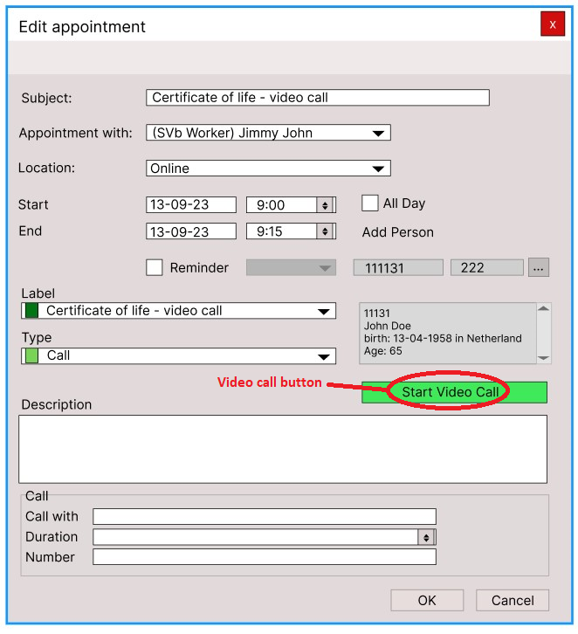

Figure : The video call button.

## The process of making a video call

There are 2 design approaches for initializing the video call process. We will go in detail how each design works and the process of how it will look like.

### First design

In this first design, after interacting with the “Start Video Call” button, The system will prompt you with a little form with the phone numbers. The purpose for this is to give the option for the worker to choose which phone numbers to video call if a retiree has 2 phone numbers.

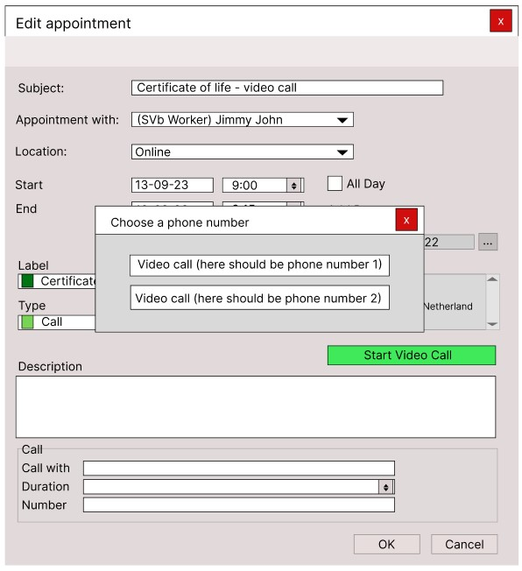

Figure : Mobile phone numbers form.

After choosing a phone number, the system attempts to contact the retiree. The worker receives visual confirmation that the system is attempting to contact the retiree, so that the worker knows what the system is doing. If the retiree didn’t answer or the worker is experiencing internet issues, the system will provide visual feedback to the worker. When the retiree answers the video call, the worker receives visual confirmation of the connection, and a live video feed appears on the screen. The retirees will receive the video call through WhatsApp.

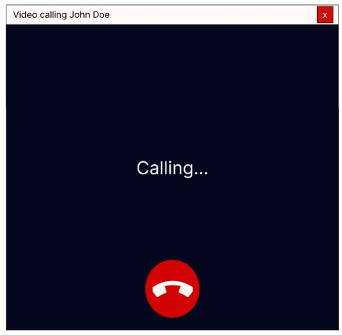

Figure : The system is calling the retiree.

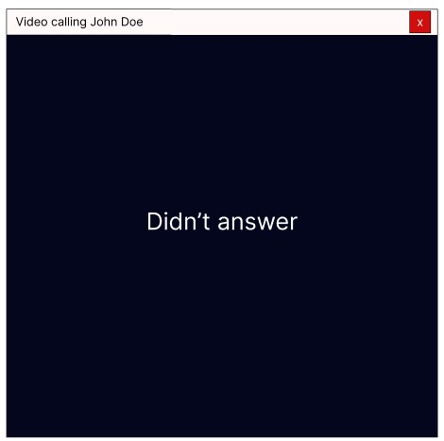

Figure : Retiree didn't answer.

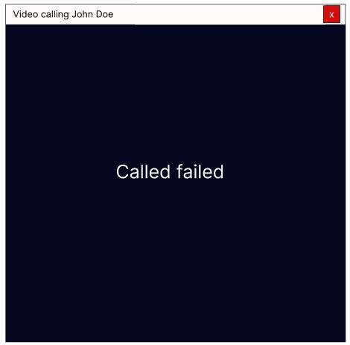

Figure : Called failed due to internet connection.

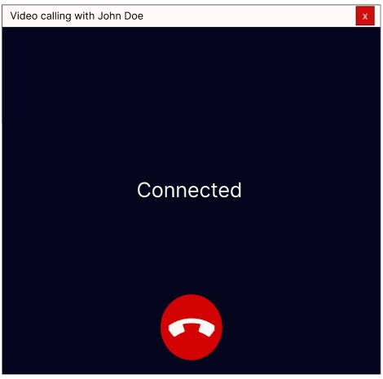

Figure : Connected with the retiree.

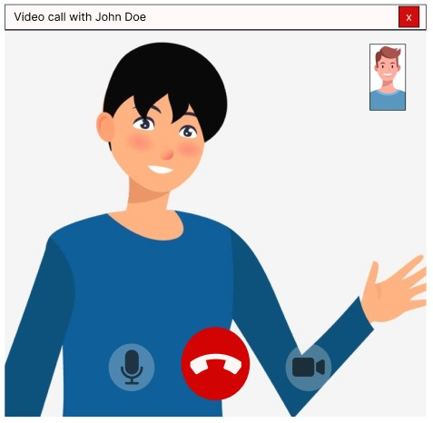

Figure : In a call with the retiree.

### Second design

In this second design this will be how to initiate a video call. Firstly, a confirmation box will appear when you click the “Start Video Call” button, asking if you are sure, you want to make this video call. The idea behind this step is to prevent accidental video calls by the workers. The worker can either choose “Yes” or “No” on the confirmation box. If “No” is selected, the confirmation box will disappear, and nothing will happen. If ‘Yes’ is chosen, the confirmation box will disappear and a new form will appear, initiating the attempt to contact the retiree.

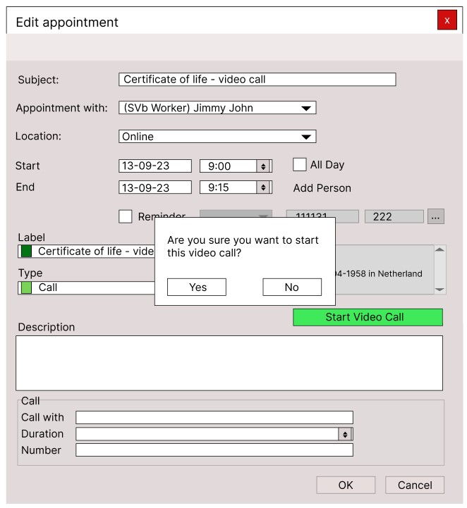

Figure : Display confirmation box.

After confirming to start a video call, the system will initiate a video call meeting. In this approach, the worker is placed in a meeting room and waits for the retiree to join the video call meeting. The system will provide visual feedback to indicate when the worker is attempting to join the room. This is similar to popular online meeting like teams and zoom. Retirees can join the meeting through the link provided in their emails or WhatsApp.

Figure : Attempting to join the room.

Figure : The worker joined the room and is waiting for the retiree.

Figure : The retiree is in the room with the worker.

## The process of end call

For ending a video call there are two ways: either by clicking the ‘End Call’ icon or the ‘Close’ button on the top right. Both options prompt a confirmation box, if you want to end the call. This is a precaution for workers who may accidently click on the ‘End Call’ icon or the ‘Close’ button. if the worker chooses ‘No,’ the confirmation box will disappear, and they’ll remain in the call. If the worker chooses ‘Yes,’ the confirmation box will disappear, the call will end, and the video call form will also disappear. This will work for both methods of initiating the video call. The first method also provides visual feedback indicating that the call has ended.

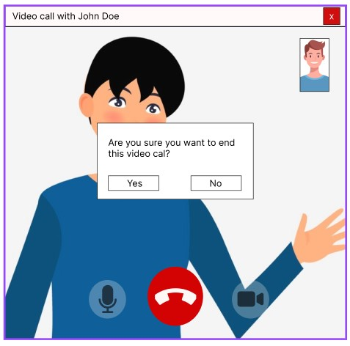

Figure : Confirmation box when the 'End Call' icon or the 'Close' button is clicked.

Figure : End call visual feedback.

## Other components

### Mute microphone

The icon for microphone will change when the user mutes the microphone. This is not essential but it’s good to have. It’s mostly for the other user in the call to avoid hearing the background noises.

Figure : Mute microphone.

### Turn off camera

The icon for the camera will change when the user turns the camera off. While not essential, it’s a helpful feature, primarily for troubleshooting camera issues because sometimes the camera won’t work initially and needs to be turned off and on again or to avoid showing personal items on the screen. Additionally, it will provide visual feedback indicating that the camera is turned off, in the top right corner of the screen.

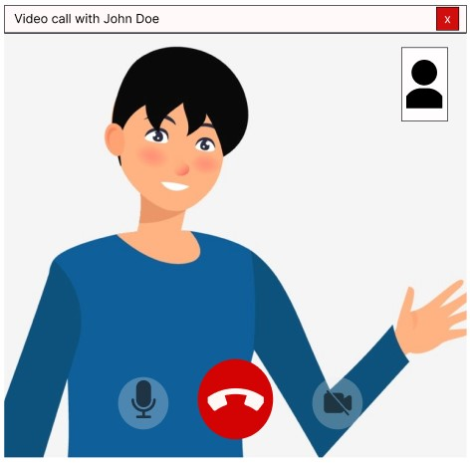

Figure : Camera is turned off.